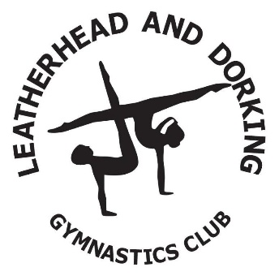

Adidas Tracksuit Order Form

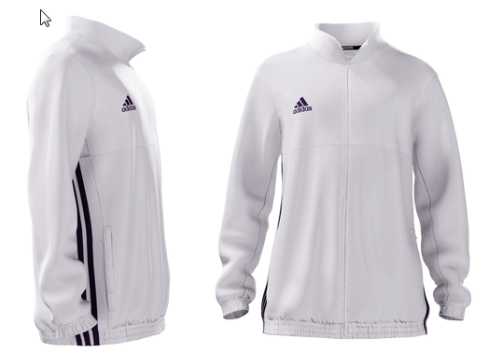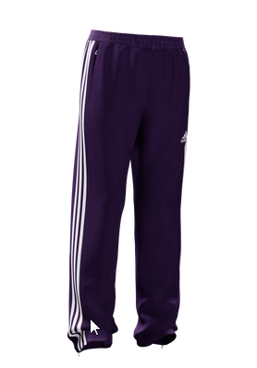

Please complete and hand into the Office.

Name of Gymnast:
Squad:

Please circle your size |  |  |  |  | Cost
Tracksuit Size: Child Sizes | 5 /6 | 7/8 | 9/10 | 11/12 | £85.00
Tracksuit Size: Youth Sizes | 13/14 |  |  |  | £100.00
Tracksuit Size: Adults | All sizes |  |  |  | £124.00

Please pay by cash, cheque or debit card
All cheques to be made payable to Leatherhead and Dorking Gymnastics Club

