LEATHERHEAD AND DORKING GYMNASTICS CLUB

DIRECTORS: MARGARET MILER/PAUL GARBER

THE GYMNASIUM, GUILDFORD ROAD,

LEATHERHEAD, SURREY KT22 9BL

TEL: 01372 377718

BRITISH GYMNASTICS NATIONAL

HIGH PERFORMANCE CENTRE

GYMNASTICS REGIONAL

CENTRE OF EXCELLENCE
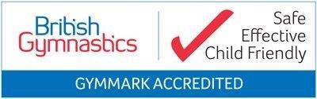
Email: Info@leatherhead-gymnastics.org.uk
Website: www.leatherhead-gymnastics.org.uk

BRITISH GYMNASTICS CHANGES ON HOW TO INSURE YOUR CHILD
UK Law requires us to change the way British Gymnastics obtains data from you as a result, legislation regarding data protection, the General Data Protection Regulation (GDPR.
The new legislation will require us to collect payments for insurance which will be held in a ‘client’ account. Once we have been given your payment we will direct you to a website link from British Gymnastics. You will need to enter your child/rens details. The Club will then be invoiced by British Gymnastics for your payment.
Please note that failure to complete the website link to insure your child/ren your fees will not be refunded and we will have to refuse entry to the gym due to non-insurance until the link has been completed.
We would like to thank all our members for their co-operation.
If you have any questions please do not hesitate to contact Liz or Vicky.

Kind regards

Margaret Miler and Paul Garber
DIRECTORS

NO CHILD CAN ENTER THE GYMNASIUM WITHOUT BRITISH GYMNASTICS INSURANCE

Dated 1st August 2017

