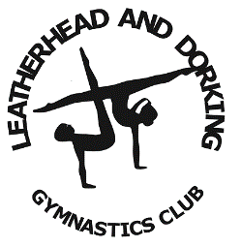
Leatherhead & Dorking Gymnastics Club
L3 Women’s Artistic Coach

Leatherhead & Dorking Gymnastics Club is a purpose built facility. We are a well-established and friendly club who train over 1200 gymnasts in Pre-school, General for All (recreational), Women’s Artistic, Men’s Artistic and Team Gym and Disability gymnastics disciplines at all levels.
We currently have 3 purpose built gymnasiums and are in the process of building a 4th gymnasium and a Disability Sensory room to expand our programme further.
The club supports and encourages the personal development of coaches.
Leatherhead & Dorking Gymnastics Club are seeking an enthusiastic and professional individual with past experience of coaching in a Club.

Successful applicants will
- Report to Head of Women’s Artistic
- Be responsible for the safeguarding and welfare of gymnasts
- Knowledge of British Gymnastics grades, levels and classic challenge
- Basic knowledge of Women’s Artistic judging
- Ability of hand spotting on bars
- To deliver quality sessions with individual programmes for each gymnast
- Ensure training programmes are followed and gymnasts are well prepared for competitions
- Liaise with Head of Women’s Artistic, parents/guardians on development of gymnasts, competitions/training requirements and progress
- Help and mentor other coaches
- Continue to develop as a coach.

Personal Specification
Applications should ideally hold the following skill set:
- Enthusiastic
- Confident
- Well organised and motivated
- Coach as part of a progressing high level coaching team
- Professional kind manner
- Good interpersonal skills
- Be flexible and adaptable to the needs of the role
- Suitable to work with children
- Approachable to the children, parents and other coaches
- Must have a good command of English with good written and verbal skills
- Basic computer skills
Qualification and Experience
- Preferred Level 3+ UKCC certificate in coaching women’s artistic gymnastics
- Current DBS certificate
- BG recognised Safeguarding documentation together with a current First Aid certificate.
- Experience in coaching Squad gymnasts
Benefits
We offer a competitive salary which is negotiable depending on qualifications and experience including a work place pension. Hours 20+ per week including evening and weekend work.
Please forward your application together with your Curriculum Vitae, which should include details of a minimum of 2 suitable work references and a personal reference. Please note that references will ideally be taken before interview so that any issues can be address at interview stage. Qualification Certificates and photo identification should be brought to interview.
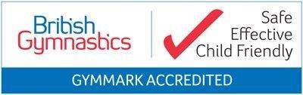
Margaret Miler, Paul Garber, Directors, and Liz Taylor Operations Director. PGarber@btinternet.com & liz.taylor@leatherhead-gymnastics.org.uk

