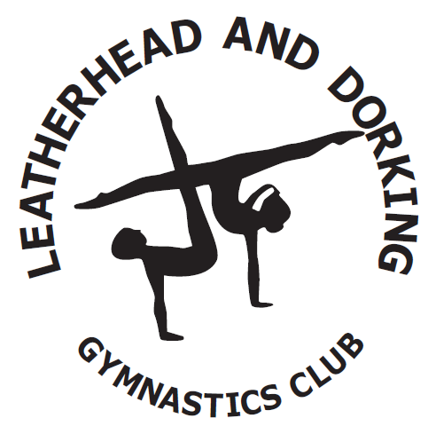

CODE OF CONDUCT FOR GYMNASTS’S PARENTS & GUARDIANS
Introduction
We are fully committed to promote the highest standard of behaviour amongst our gymnasts in all situations; hence we are introducing this Code of Conduct for all our valued members.

- When visiting Leatherhead & Dorking gymnastics Club please sign in your child at reception and let reception know if someone else is collecting your child.

- It is essential that all parents, guardians and visitors to the club take great care when parking or “dropping off”. Please observe the double yellow lines and the hatched area where there should be NO PARKING at any time.

- Parents are required to accompany their children to and from the gymnasium; coaches will ensure safe dismissal of gymnasts to their parents. We would appreciate your child being collected promptly from inside the Club, following their session, if you’re running late please contact reception as soon as possible, failure to do so will result in the following course of action:
- First contact – call will be made if more than 10 minutes late.
- Second contact – call at 20 minutes late.
- Third contact - call at 30 minutes late.
- Repeat offenders (on more than 2 occasions a week) – discussion with parents about the welfare of the child
- Persistent offenders will be referred to our Welfare officer and they will inform the GP and social services.

- Pushchairs are not permitted in the club due to fire hazard regulations, they can be left outside under the canopy.

- Parents are not allowed to enter the gymnasium at any time, unless invited by a coach, briefly to collect young children or at organised events (fun in the foam drop-in sessions, competitions, fundraising etc.) Conversations with coaches should be kept until after the session is completed.
- Please ensure you notify us of any change of address, telephone number or medical conditions.

- All gymnasts are required to wear appropriate clothing for their discipline, jewellery is prohibited and long hair should be tied back. All male gymnasts are required to have their hair such that their forehead and back of their neck is fully visible at all times. Fingernails should be kept short so as not to scratch or harm the coach or other participants during training. Do not wear false nails or acrylic nails when participating in gymnastics.

- Maintain good standards of behaviour at all times. Treat all your coaches, officials and staff members with respect and dignity, value their input into your development and be polite.
- Treat all your gymnasts’ friends with respect and always support each other as part of a team.
• Never leave valuables in the changing rooms. Where possible please leave all valuables at home. The club cannot be held responsible for the loss of any items.
• Do not climb on or use any equipment unless supervised and instructed to do so by a coach as part of your training.
• Listen carefully and follow the instructions of the coaches at all times.
- Gymnast must inform their coach of any injuries or illness they may have before the start of the training session.
• Gymnasts are not allowed to eat food inside the gymnasium or chewing gum or consume fizzy drinks, any snacks and water bottles can be kept in the changing rooms and consumed following permission from their coach.
- Be polite and considerate to others, be patient; wait for your turn sensibly. As a member of L&DGC using bad language is not allowed.

- Any form of bullying and harassment will not be tolerated and if you feel affected please report it immediately to your coach or welfare office whom are also available for any confidential issues you wish to discuss.
Parents Section

- Encourage your child to learn the rules and participate within them.

- Discourage challenging / arguing with officials.

- Share any concerns or complaints about any aspect of the club with the coach/ head of discipline/ official in the first instance.

- Use correct and proper language at all times.

- Food and drink are not permitted inside the gymnasium. We do have a kitchen area for children to eat and drink their own supplies. Water is supplied in the changing rooms via water fountain.

- The Club has adopted and works closely within the policies and guidelines of British Gymnastics. If you have any concerns regarding the welfare of any of our gymnast you can contact the relevant Welfare Officer either at welfare@leatherhead-gymnastics.org.uk or on 01372 377718. Confidentially applies to all welfare issues.

- Jane Redgewell – Principle Welfare Officer with particular responsibility for General Gymnastics.
- Kevin Littell – Welfare Officer with particular responsibility for Squad Boys.
- Paula Bruce – Welfare Officer with particular responsibility for Squad Girls.

- Gymnasts, Parents, Guardians and Coaches must not post unfavourable personal or disrespectful comments regarding gymnasts, coaches, club personnel, the club or any other club on social media such as Twitter and Facebook. If you become aware that the above is occurring please contact the club welfare Officer.

- The Club does have a Child Protection Policy Statement which can be obtained from the Club.

- The club must be made aware of any disability or medical condition in order that our coaching team can coach provide the correct level of support/guidance.

General Gymnastic Classes

- Leatherhead and Dorking Gymnastic Club is suitable for children 4 years and over who are at full-time school.

- Light, stretchy clothing should be worn and no shoes but socks for trampolining.

- Our courses run through school holidays but we are closed on Bank Holidays.

- We regret missed classes cannot be made up.

Kindergym and Preschool Classes

- Leatherhead and Dorking Gymnastic Club is suitable for children age 18 months – 3 years and 3 years to 5 years old.

- Light, stretchy clothing should be worn and no shoes but socks for trampolining.

- We regret missed classes cannot be made up.

